Office of Sponsored Programs Spotlight
Fitness Restoration/Interwoven Counseling Center
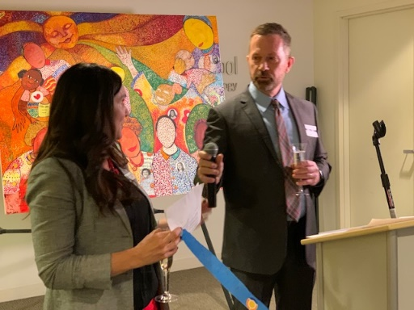
The Forensic Center operates a widely respected Fitness Restoration Program, which provides services to persons found incompetent to stand trial with the goal of fitness restoration. The outpatient Fitness Restoration program delivered by licensed mental health professionals who provide community-based fitness restoration services, which include psychiatric, mental health and substance abuse treatment services, as well as legal education, for individuals found Unfit to Stand Trial (UST) by the Cook County Criminal Courts and remanded by court-ordered outpatient forensic restoration and treatment services. The program is designed to reduce the number of individuals determined to be UST, with mental illness and/or co-occurring psychiatric and substance use disorder, on the State Mental Health Hospital waiting list for inpatient fitness restoration services and to increase the prompt access to clinically appropriate outpatient fitness restoration services for individuals determined to be UST who do not require the restrictiveness of a hospital setting.
Michael Russell, Executive Director – Interwoven Grand Opening

Now in its sixth year under the direction of Michael Russell, the program is currently funded by a 3-year, $1.1 million grant from the Illinois Department of Human Services (IDHS). In seeking continuation of the grant for an additional 3-year cycle, and having established itself as the only formalized fitness restoration program in Illinois, the Forensic Center proposes to expand the scope of the program to include Chicago suburban collar counties through the implementation of a technology and training center to develop fitness restoration services throughout Illinois.
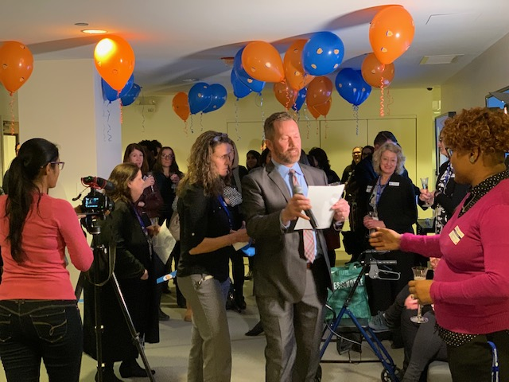
As a result of the funding from IDHS, on January 22, 2020, The Chicago campus successfully launched the Interwoven Community Counselor Center with more than 100 faculty, staff, students, community partners, and other supporters in attendance at a special launch celebration. Interwoven will operate out of the current Forensic Center facility and will serve as the new home for the Forensic Center. In addition to providing affordable and accessible services to the general community, a core purpose in launching Interwoven is to operationally and fiscally support the critical services provided by the Forensic Center to underserved and less privileged communities.
In addition to providing community mental health services, Interwoven is a training center, and plans include continued collaboration with academic departments to further build out applied learning opportunities for students.

