TCS Education System VPN Connection for Mac OS-X

This document describes how to download, install and connect to TCS Education Systems Cisco AnyConnect VPN solution using Mac OS-X v10.7 or later.
- Open Safari (or whatever browser you choose) and navigate to vpn.tcsedsystem.edu
- You will be presented with a login box. Select your proper group(TCSedsystem) from the drop down box and enter your network credentials: 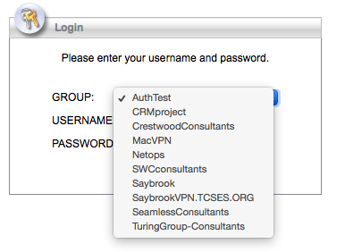
- Once your credentials are entered, the software will begin to download
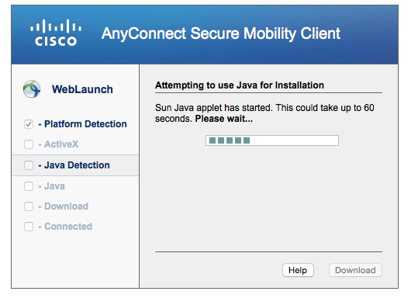
- The install should complete automatically. Depending on the version of Java installed, you may see the following. If not, skip to step 10.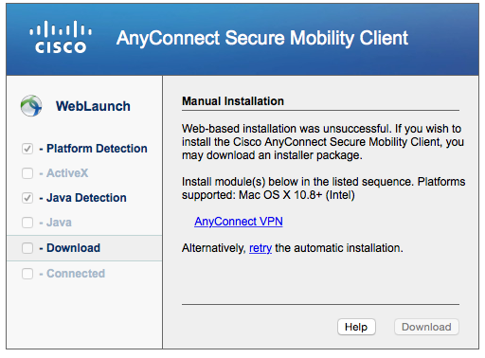
- Click on the AnyConnectVPN link in the dialog box. This will download the installer .pkg file to your hard drive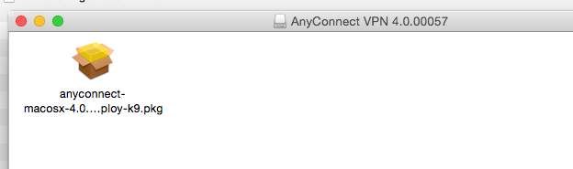
- Using Finder, navigate to your download folder and click the downloaded file. You will be presented with the installation screen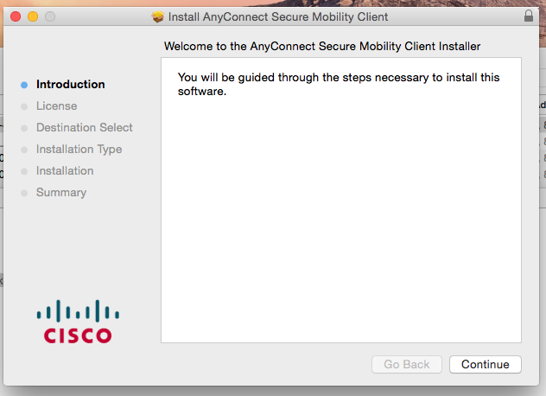
- Accept the License Agreement by clicking Continue and Agree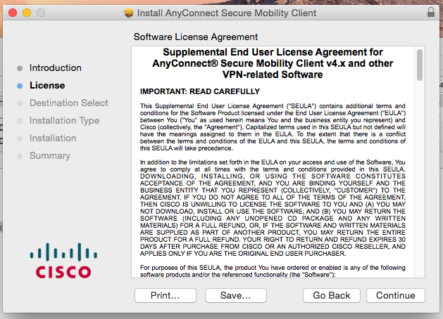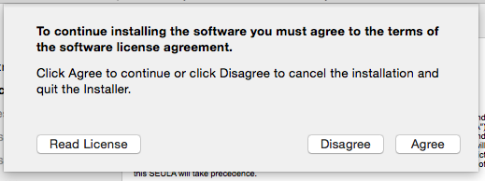
- Click the “install” button on the following screen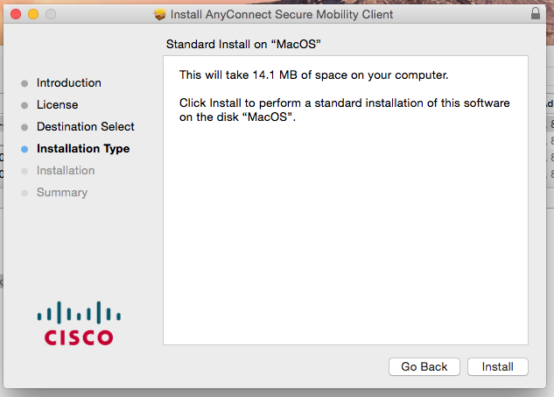
- Enter your local Mac password (if requested) 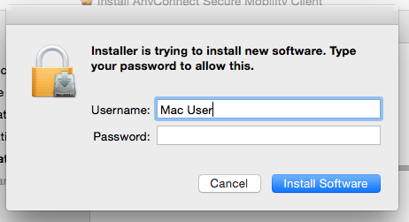
- The install should complete successfully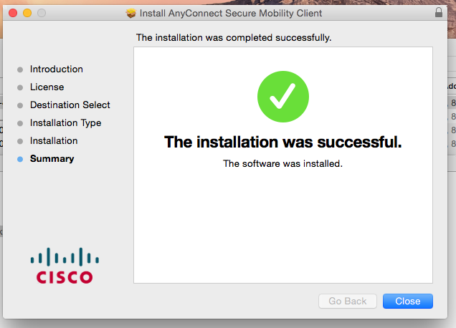
- Launch the installed program and enter vpn.tcsedsystem.edu and click connect. Select your group (TCSedsystem.edu) and enter your network credentials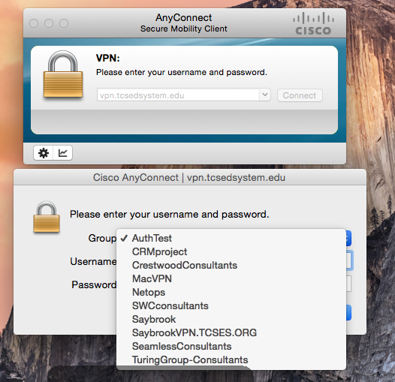
- After a few seconds, the screen will show “connected to vpn.tcsedsystem.edu” 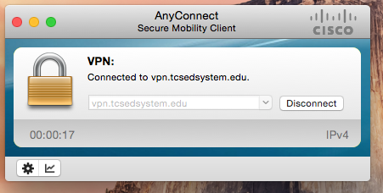
- Please remember to click the “Disconnect” button when done using the VPN

