TCS Education System VPN Installation

This document describes the procedure for downloading and installing the TCS Education System VPN client and connecting to the corporate network.
- Open Internet Explorer and navigate to https://vpn.tcsedsystem.edu. Must be Off our Corporate network to connect to URL
- Select your group (TCSEdsystem) and enter your network credentials:
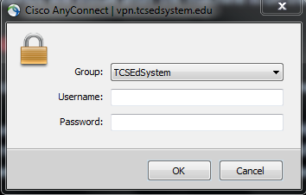
- You will be prompted to install the VPN client software: 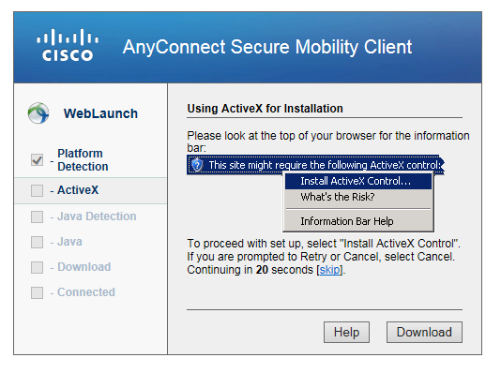
- Click on the “Do not show this again” and click RUN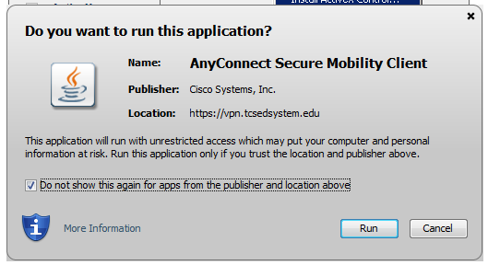
- The installer will complete. Navigate to the “Cisco” program group and select “Cisco AnyConnect Secure Mobility Client”
- Click “Connect” and choose your group (tcsedsystem) and enter your credentials
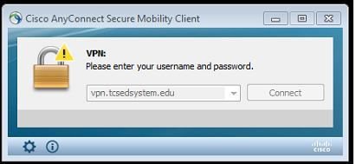
- Your VPN software will have a green check mark and show “Connected”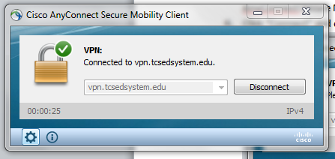

- Be sure to click the “Disconnect” button when finished working!

