Virtual Graduate Research Forum
Digital Poster and Video Narrative Guidelines

For this year’s Graduate Research Forum, all students will be required to create a digital “poster” and a video/voiceover narrative accompanying the poster to create a holistic presentation for faculty judges to review. There will also be an opportunity for judges and virtual guests to leave comments for each presentation, which we will expect participants to respond to in a timely manner. All GRF presentations will be on the official TCSPP GRF website.

Presentations will be judged by the following criteria:
- Clarity of purpose
- Appropriateness of methodology
- Interpretation of results
- Value of research or creative activity
- Ability of the presenter to articulate the research of creative activity (video)
- Organization of the material presented (digital poster)
- Presenter’s ability to handle questions from jury and audience

Digital Poster Guidelines:
- We recommend that you create your virtual poster presentation in PowerPoint or as a PowerPoint template on Canva (or a similar content editing program like Prezi)
- We encourage you to follow APA poster presentation guidelines when applicable
- Use large text for the title of your research (but do not use all capital letters in the title)
- Include the author(s) and a description of the research that highlights the major elements
- Be sure to provide a clear label for each section of your presentation (highlighting the subject, purpose, methodology, and results if applicable) and create a logical reading flow of the poster
- A copy of your abstract (300 words or less), in large typescript, should be posted in the upper left-hand corner of the poster
- Minimize detail in descriptions and avoid excessive amounts of information in general
- Use pictures, tables, and figures to illustrate concepts and add interest to the poster
- All of your text should be in a size easy to read and preferably in a bold font

Video/Voiceover Narrative Guidelines
- This video should be a brief (3-5 minute) summary of your poster and research and can be one of the following formats:
  - Record the narrative directly on PowerPoint using the “Insert Audio” function
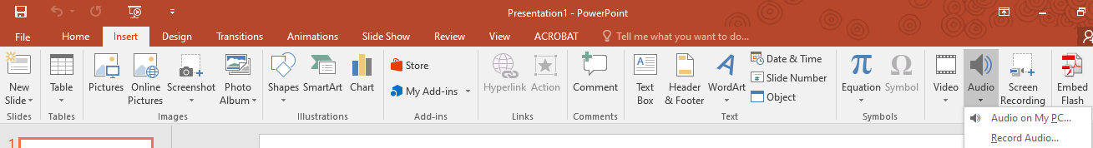
  - Record a video of yourself, the presenter, speaking to the camera, as if you’re presenting in front of a live audience
    - We will be uploading the videos you send to us to our YouTube channel for posting to the GRF website, so please be sure the video recording is in one of the following formats: 3GPP, AVI, FLV, MOV, MPEG4, MPEGPS, WebM and WMV (most smartphones record MPEG4 videos)
    - Please be sure to record your video with a horizontal orientation
    - We do not recommend you film your video like a “selfie” – instead, prop your phone or video recorder up and film yourself from an appropriate distance
- We do not recommend you just read off your poster for your recorded narrative (since judges and guests can just read it themselves)
  - Instead, use your recorded narrative to add value to your poster and point out the most important aspects of your research project (highlighting the subject, purpose, methodology, and results if applicable)
- Create an outline of your narrative before filming/recording to make sure you have a logical flow and present professionally

Additional Resources/Tips
- PowerPoint Poster Templates
  - Option 1
  - Option 2
- Giving an Effective Poster Presentation
- How to Present an Academic Research Poster
- Poster Presenting Tips
- How to Give a Great Presentation
- TED’s Secret to Great Public Speaking
- Six Public Speaking Tips to Hook Any Audience
- If your GRF project is your dissertation, you may want to consult with your Dissertation Chair for support and guidance on organizing and presenting the material
- The Writing Center is a great resource for ensuring you’re following APA guidelines, writing concisely, etc.

